1. A hollow fiber has a diameter of 100 m and a length of 5 cm. The pore diameter is  cm. The inlet flow velocity is 20 cm/s. The temperature is 37 , and the kinematic viscosity of the solvent at this temperature is 0.007 .

|  |  |  |
| --- | --- | --- |
| **Prob #** | **Points** | **Max** |
| **1a** |  | **10** |
| **1b** |  | **10** |
| **1c** |  | **10** |
| **1d** |  | **10** |
| **2a** |  | **25** |
| **2b** |  | **10** |
| **3** |  | **10** |
| **4a** |  | **10** |
| **4b** |  | **10** |
| **Total** |  | **105** |

a. What is the nominal molecular weight cutoff (NMWC)?

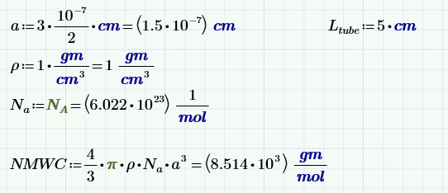

b. Find the momentum entry length, $L_{e}$.

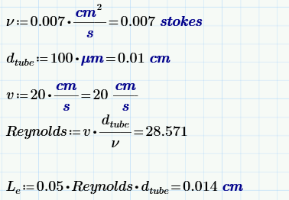

c. Find the concentration entry length, $L_{c}$, if the molecular weight of the solvent is 2500.

**Answer:**

I intended to give you the molecular weight of the solute in this problem, so that you would need to calculate $D_{AB}$. Unfortunately, Word crashed after I finished the exam, and the molecular weight did not get inserted back in when I went back and patched up the exam. Therefore, you were left to your own devices to figure out a value for $D_{AB}$.

$$L_{c}=0.05 \text{Re} d_{\text{tube}} \text{Sc}=L_{e} \text{Sc}$$

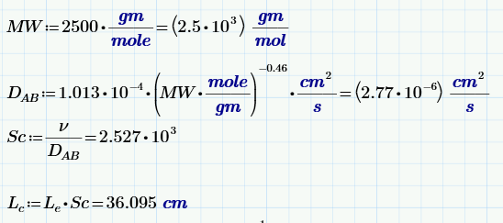

d. Given these entry lengths, select the appropriate Sherwood number from Table 5.1, and calculate the Sherwood number.

**Answer:**

We have a developed momentum boundary layer and an undeveloped concentration boundary layer (as long as you use a reasonable value for $D_{AB}$). Therefore, the short contact time solution is the most appropriate.

$$\text{Sh}=1.86{\left(\frac{ρd_{\text{tube}}v}{μ}\frac{μ}{ρD_{AB}}\frac{d_{\text{tube}}}{L}\right)}^{\frac{1}{3}}$$

You could also use the correlation with a coefficient of 1.615 instead of 1.86.

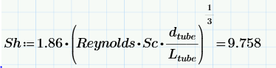

1. A solute of molecular radius $2×{10}^{-8}$ cm flows through a hollow fiber tube, where the pore radius for the tube is $6×{10}^{-8}$ cm. Assume that the mass transfer coefficient is $9.5×{10}^{-5}$ cm/s and that the hydraulic conductivity of the membrane is $L_{p}=5×{10}^{-7}\frac{cm}{Pa s}$. The concentration of the molecule in the solvent is 0.05 moles/liter. The mechanical pressure difference across the membrane is 20 mm Hg (1 mm Hg = 1 torr), and the osmolarity on the two sides of the membrane can be considered equal.
2. Find the observed sieving coefficient.

**Answer:**

The equation for the observed sieving coefficient is

$$S_{0}≡\frac{C_{filtrate}}{C_{bulk}}=\frac{S_{a}}{\left(1-S_{a}\right)e^{- \frac{q}{k_{m}}}+S_{a}} ,$$

We must first calculate the actual sieving coefficient, according to

$$S_{a}={\left(1-\frac{a}{r}\right)}^{2}\left[2-{\left(1-\frac{a}{r}\right)}^{2}\right]\left[1-\frac{2}{3}{\left(\frac{a}{r}\right)}^{2}-0.163{\left(\frac{a}{r}\right)}^{3}\right]$$

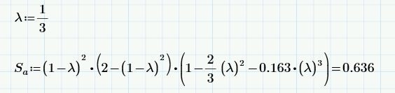

Next, we need to find $q$.



$$q=L_{p}(ΔP-Δπ)$$

The mass transfer coefficient was given in the problem statement, so we can now calculate the observed sieving coefficient.



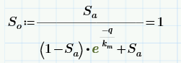

1. If the concentration of the protein inside the tube is 200 mg/L, find the total mass flux, assuming that the protein concentration does not change along the length of the tube. Assume that the tube diameter is 100 $μm$ and that the tube length is 10 cm.

**Answer:**

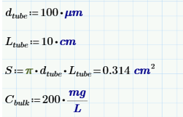



1. You are asked to analyze a situation where culture medium is fed through a hollow fiber. The fiber is coated with a drug with $C_{AS}=100 \text{mg}/\text{L}$. For each of the two cases below, state whether you would need to use the log-mean concentration in the calculation for $\dot{m}$, and explain why or why not (one or two sentences). Assume that you need the solution to be correct by only 5%.
2. The inlet concentration is 0, and the outlet concentration is 1 mg/L.
3. The inlet concentration is 40 mg/L, and the outlet concentration is 80 mg/L.

**Answer:**

The first situation does not require the log-mean concentration because the difference between the concentration at the wall and the concentration in the tube is essentially constant throughout the tube length.

The second situation does require the log mean concentration because the difference between the concentration at the wall and the concentration in the tube changes significantly (by a factor of three).

1. A mass transport problem in a spherical geometry has the following governing partial differential equation
$$\frac{∂}{∂r}\left(r^{2}\frac{∂C}{∂r}\right)+\frac{1}{\sin{θ}}\frac{∂}{∂θ}\left(\sin{θ}\frac{∂C}{∂θ}\right)=0$$

2. Assume that the concentration can be written as

$$C=R\left(r\right)Θ\left(θ\right)$$

and find the two ordinary differential equations, through separation of variables, for the functions $R(r)$ and $Θ\left(θ\right)$.

**Answer:**

$$\frac{∂}{∂r}\left(r^{2}\frac{∂RΘ}{∂r}\right)+\frac{1}{\sin{θ}}\frac{∂}{∂θ}\left(\sin{θ}\frac{∂RΘ }{∂θ}\right)=0$$

$$Θ\frac{∂}{∂r}\left(r^{2}\frac{∂R}{∂r}\right)+\frac{R}{\sin{θ}}\frac{∂}{∂θ}\left(\sin{θ}\frac{∂Θ }{∂θ}\right)=0$$

$$\frac{1}{R}\frac{∂}{∂r}\left(r^{2}\frac{∂R}{∂r}\right)+\frac{1}{Θ}\frac{1}{\sin{θ}}\frac{∂}{∂θ}\left(\sin{θ}\frac{∂Θ }{∂θ}\right)=0$$

$$\frac{1}{R}\frac{∂}{∂r}\left(r^{2}\frac{∂R}{∂r}\right)=λ^{2}; \frac{1}{Θ}\frac{1}{\sin{θ}}\frac{∂}{∂θ}\left(\sin{θ}\frac{∂Θ }{∂θ}\right)={-λ}^{2}$$

$$\frac{∂}{∂r}\left(r^{2}\frac{∂R}{∂r}\right)-λ^{2}R=0⇒r^{2}\frac{d^{2}R}{dr^{2}}+2r\frac{dR}{dr}+λ^{2}R=0$$

$$\frac{1}{\sin{θ}}\frac{∂}{∂θ}\left(\sin{θ}\frac{∂Θ }{∂θ}\right)+λ^{2}Θ=0$$

1. Refer to the handout on basic differential equations to deduce the form of the solutions for $R(r)$ and $Θ\left(θ\right)$.

The first equation is equidimensional, with solutions of the form $r^{n}$. The second is Legendre’s equation, with solutions of the form

$$f=A P_{n}\left(\cos{θ}\right)+B Q_{n} \left(\cos{θ}\right)$$

**Potentially Useful Formulas**

# Solute Flux

$$Π=RTC_{s} \text{van't Hoff's law}$$

$$J=L_{p}S\left[\left(P_{c}-P_{IF}\right)-\left(π_{c}-π_{IF}\right)\right]=L_{p}SΔ\overline{P}$$

$$L_{p}=\frac{A_{p}}{S}\frac{R_{\text{pore}}^{2}}{8μτt_{m}}$$

$$ε=\frac{A_{p}}{S}$$

$$S_{a}={\left(1-\frac{a}{r}\right)}^{2}\left[2-{\left(1-\frac{a}{r}\right)}^{2}\right]\left[1-\frac{2}{3}{\left(\frac{a}{r}\right)}^{2}-0.163{\left(\frac{a}{r}\right)}^{3}\right]$$

$$S_{0}≡\frac{C_{filtrate}}{C_{bulk}}=\frac{S_{a}}{\left(1-S_{a}\right)e^{- \frac{q}{k_{m}}}+S_{a}} ,$$

# Nernst Equation

$$V=\frac{RT}{zF}\ln{\frac{C\text{outside}}{C\text{inside}}}$$

# Error Function

$$\operatorname{erf}\left(x\right)≡\frac{2}{\sqrt{π}}\int_{0}^{x}{e^{-η^{2}} ⅆη}$$

$$\operatorname{erfc}\left(x\right)=\left(1-\operatorname{erf}\left(x\right)\right)$$

# Differential Equations

|  |  |
| --- | --- |
| $$\frac{df}{dt}+αf=0$$ | $$f=A e^{-αt}$$ |
| Fourier Equation $$\frac{d^{2}f}{dt^{2}}+ α^{2}f=0$$ | $$f=c_{1}\cos\left(αt\right){+c}_{2}\sin\left(αt\right)$$ or $f=A_{1}{ e}^{i αt}+A_{2}e^{-iαt}$ |
| Similar to 4, but with negative linear term $$\frac{d^{2}f}{dt^{2}}- α^{2}f=0$$ | $$f=c_{1}\cosh\left(αt\right)+c_{2}\sinh\left(αt\right)$$ or $f=A_{1}{ e}^{ αt}+A_{2}e^{-αt}$ |

**Fick’s First Law of Diffusion**

$$j_{s}=-D_{AB}\frac{dC}{dy} \frac{\text{moles}}{{\text{cm}}^{2}\text{s}} \text{Where} j_{s} \text{is solute flux} \text{per unit area}$$

$$D_{AB}(\text{in cm}\text{2}\text{/sec)}=1.013×{10}^{-4}{\left(MW\right)}^{-0.46} \text{Empirical Model}$$

$$D_{AB}=\frac{RT}{6πμaN_{a}} \text{Stokes-Einstein}$$

$$a={\left(\frac{3MW}{4πρN_{A}}\right)}^{\frac{1}{3}} \text{Molecular Radius}$$

$${\left.j_{s}\right|}_{\text{surface}}=k_{m}\left(C_{\text{high}}-C_{\text{low}}\right) \text{Definition of mass transfer coefficient}$$

# Non-Dimensional Parameters

Let $V$ be a characteristic velocity, $d$ be a characteristic length, $ν$ be kinematic viscosity,

$$Re_{d}≡\frac{Vd}{ν} \text{Reynolds number}$$

Further, let $D$ be diffusion coefficient.

$$Sc≡\frac{μ}{ρD_{AB}}=\frac{ν}{D_{AB}} \text{Schmidt number}$$

Let $k_{m}$ be the mass transfer coefficient.

$$Sh_{x}≡\frac{k_{m}x}{D_{AB}} \text{Sherwood number}$$

$$\text{Pe}=\frac{Vd}{D_{AB}} \text{Peclet number}$$

$$\text{Da}=\frac{ϕΓδ^{2}}{D_{T}C_{\text{oxygen}}^{\text{in}}} \text{Damkholer number}$$

# General Mass Transport Equation (Fick’s Second Law)

$$\frac{∂C}{∂t}+v⋅∇C=D∇^{2}C+R_{a}$$

In Cardesian coordinates

$$\frac{∂C}{∂t}+v_{x}\frac{∂C}{∂x}+v_{y}\frac{∂C}{∂y}+v_{z}\frac{∂C}{∂z}=D\left(\frac{∂^{2}C}{∂x^{2}}+{\frac{∂^{2}C}{∂y}}^{2}+\frac{∂^{2}C}{∂z^{2}}\right)+R_{a}$$

In cylindrical coordinates

$$\frac{∂C}{∂t}+v_{r}\frac{∂C}{∂r}+\frac{v_{θ}}{r}\frac{∂C}{∂θ}+v_{z}\frac{∂C}{∂z}=D\left(\frac{1}{r}\frac{∂}{∂r}\left(r\frac{∂C}{∂r}\right)+\frac{1}{r^{2}}\frac{∂^{2}C}{∂θ^{2}}+\frac{∂^{2}C}{∂z^{2}}\right)+R_{a}$$

In spherical coordinages

$$\frac{∂C}{∂t}+v_{r}\frac{∂C}{∂r}+\frac{v_{θ}}{r}\frac{∂C}{∂θ}+\frac{v_{φ}}{r\sin{θ}}\frac{∂C}{∂φ}$$

$$=D\left(\frac{1}{r^{2}}\frac{∂}{∂r}\left(r^{2}\frac{∂C}{∂r}\right)+\frac{1}{r^{2}\sin{θ}}\frac{∂}{∂θ}\left(\sin{θ\frac{∂C}{∂θ}}\right) +\frac{1}{r^{2}\sin^{2}{θ}}\frac{∂^{2}C}{∂φ^{2}}\right)+R_{a}$$

# Boundary Layer Development

Pipe flow, fully developed momentum boundary layer $\frac{z}{d_{tube}}=0.05 \text{Re}$.

Pipe flow, fully developed concentration boundary layer $\frac{z}{d_{tube}}=0.05 \text{Re Sc}$.

Flat plate, laminar boundary layer $\text{Re}<300,000$.

Cylinder, laminar flow $\text{Re}<2,000$.

# Constants

Avagadro’s Number: $6.023 × {10}^{23} \text{atoms}/\text{mole}$

Faraday’s Constant: $F=2.3×{10}^{4} \frac{\text{cal g}}{\text{Volt mole}}$

Universal Gas Constant: $R=8.314\frac{Joule}{mole Kelvin}$

Centigrade to Kelvin: Degrees Kelvin $=$ 273.15 $+$ Degrees Centigrade

**Table of Laplace Transforms**

|  |  |  |
| --- | --- | --- |
| 1 |  | 1 |
| 2 |  |  |
| 3 |  |  |
| 4 |  |  |
| 5 |  |  |
| 6 |  |  |
| 7 |  |  |
| 8 |  |  |
| 9 |  |  |
| 10 |  |  |
| 11 |  |  |
| 12 |  |  |
| 23 | $$\frac{x}{2\sqrt{πat^{3}}}e^{- \frac{x^{2}}{4at}} u_{s}\left(t\right)$$ | $$e^{-\sqrt{\frac{s}{a}}x}$$ |
| 24 | $$\sqrt{\frac{a}{πt}} e^{- \frac{x^{2}}{4at}} u_{s}\left(t\right)$$ | $\sqrt{\frac{a}{s}}$ $e^{-\sqrt{\frac{s}{a}}x}$ |
| 25 | $$erfc\left(\frac{x}{2\sqrt{at}}\right)u_{s}\left(t\right)t)t(p l ordinatesfficient.$$ | $$\frac{e^{-\sqrt{\frac{s}{a}}x}}{s}$$ |
| 26 | $$\left[2\sqrt{\frac{at}{π}} e^{-\frac{x^{2}}{4at}}-x erfc\left(\frac{x}{2\sqrt{at}}\right)\right]u_{s}\left(t\right)t)t(p l ordinatesfficient.$$ | $$\frac{\sqrt{a}}{\sqrt{s^{3}}} e^{-\sqrt{\frac{s}{a}}x}$$ |
| 27 | $$\left[\left(t+\frac{x^{2}}{2a}\right)erfc\left(\frac{x}{2\sqrt{at}}\right)-x\sqrt{\frac{t}{πa}} e^{-\frac{x^{2}}{4at}}\right]u_{s}\left(t\right)$$ | $$\frac{1}{s^{2}}e^{-\sqrt{\frac{s}{a}}x}$$ |